**Sternberg**

# Introduction

This paper examines short term memory search using the Sternberg task. Through measures of reaction time (RT) and accuracy (ACC) of responses in the recognition task it will seek to determine the memory search strategy participants (Ps) used. The Sternberg task, rests on an assumption of the stage theory, in which it is assumed that cognitive processes unfold in discrete stages, which may be measured experimentally (Sternberg, 1969). The level of abstraction of the encoding stage is also examined.

## Expectations

Expectations are that Ps will perform

1. Serial search evident as higher RT at greater set size
2. Exhaustive search apparent if the slopes of RT-curves were to be similar within masking-conditions
3. Unmasking in the encoding stage appearing as a higher zero-intercept for masked probes but similar slopes within probe conditions.

# Method

This experiment included *N* = 194 participants, all psychology students at UCPH. Age and sex differences were not considered.

## Materials

* Computer with E-Prime® files for the Sternberg task

## Procedure

The experiment consisted of 12 blocks of 12 trials, each consisting of a memory set and a probe. Memory sets consisted of either two, three, or five letters and were exposed in their entirety to the P for 500 ms per letter, following 1000 ms of a fixation cross. A blank screen followed for 1000 ms, before the probe was displayed. The probe could be either masked or unmasked single letters and remained on screen until the P had indicated whether the probe was present in the memory set by pressing 1 for yes and 2 for no on the keyboard. After giving an answer, the next trial commenced.

Measures of RT consider only correct responses. Statistical analyses were carried out using SPSS.

# Results

Figure 1 displays the effect of set size, masking, and the presence of the probe on RT. A clear trend reveals itself in which masking, probe absence and increases in set size increase RT.

The slopes for present and absent probes are very similar, indicating that Ps perform a serial exhaustive search.

Figure 1: Average RT for each set size, masking and probe condition

To test whether the effects of set size and probe were significant, a repeated measures ANOVA was conducted.

It showed significant main effects of set size, *F*(1.48, 286.14) = 278.39, *p* < .001, $η_{p}^{2}$ = .59 (Huyhn-Feldt corrected), and probe, *F*(1, 193) = 58.49, *p* < .001, $η_{p}^{2}$ = .23, but no significant interaction between the two, *F*(1.90, 366.60) = 2.05, *p* = .13, $η_{p}^{2}$ = .01 (Huyhn-Feldt corrected).

The linear increase in RT with set size proving significant indicates that Ps perform a serial search. Probe presence also significantly affects RT. Figure 1 shows that negative responses take longer. There is no interaction between the two, meaning that the influence of set size on RT is similar regardless of the probe condition, indicating an exhaustive search method.

## The labour of unmasking to search

To investigate the effect of masking, also displayed in Figure 2, a repeated measures ANOVA of the effect of set size and masking on RT was conducted.

The test showed significant main effects of set size, *F*(1.38, 265.51) = 462.24, *p* < .001, $η_{p}^{2}$ = .71 (Huyhn-Feldt corrected), and masking, *F*(1, 193) = 273.39, *p* < .001, $η_{p}^{2}$ = .59, but no significant interaction between set size and masking, *F*(1.84, 354.66) = 0.55, *p* = .56, $η_{p}^{2}$ = .003 (Huyhn-Feldt corrected).

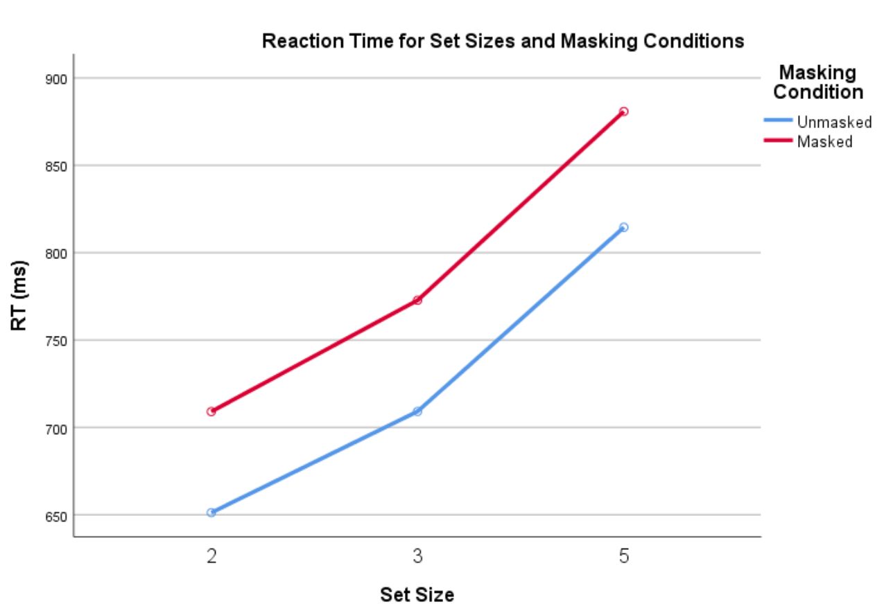

Figure 2: Graph showing RT as function of set size for each masking condition

Again, the effect of set size on RT is evident. This effect is similar for both masking conditions, as confirmed by the lacking interaction and similar slopes of the two lines. The effect of masking is apparent by the differing intercepts, placing the masked probes at a constantly higher RT. This hints that the unmasking of the probe occurs in the encoding stage.

Paired samples *t*-tests (two-tailed, a = .05) were then conducted to test the statistical validity of these claims.

They showed a significant difference between the intercepts of graphs for masked and unmasked conditions, *t*(193) = -5.68, *p* < .001, *d* = 0.38, but no significant difference between the slopes of the graphs *t*(193) = -0.89, *p* = .38, *d* = 0.07, corroborating the notion of an initial unmasking during the encoding stage followed by a search and comparison on similar terms to the unmasked condition.

## Several factors influence accuracy

Figure 3 displays the effect of set size, masking, and the presence of the probe on ACC. The effect of probe is the most immediately apparent, as the lines for absent probes are noticeably higher in the graph.

Figure 3: Graph showing average accuracy as function of set size for all four (presence/masking) conditions

A repeated measures ANOVA showed significant main effects of set size, *F*(2, 386) = 17.04, *p* < .001, $η_{p}^{2}$ = .08, masking, *F*(1, 193) = 9.25, *p* = .003, $η_{p}^{2}$ = .05, and probe, *F*(1, 193) = 118.64, *p* < .001, $η_{p}^{2}$ = .38, significant interactions between set size and masking, *F*(1.88, 363.26) = 6.64, *p* = .002, $η_{p}^{2}$ = .03 (Huyhn-Feldt corrected), between masking and probe, *F*(1, 193) = 44.80, *p* < .001, $η_{p}^{2}$ = .19, and between set size, masking, and probe, *F*(2, 386) = 7.27, *p* < .001, $η_{p}^{2}$ = .04, but no significant interaction between set size and probe, *F*(2, 386) = 0.05, *p* = .95, $η_{p}^{2}$ = 0.00.

Set size, masking and probe presence all influence ACC. The observed higher ACC for absent probes proved significant. Set size, however, influences ACC differently depending on the masking condition. In Figure 3 this is particularly apparent in the difference between the two lines representing the present condition, in which masking seems to be even more effective in increasing difficulty for greater set sizes.

The influence of masking depends on probe presence. ACC for absent probes is highest when they are masked, while present probes generate more accurate responses when unmasked (Figure 3).

## Speed/accuracy trade-off

To test for a speed/accuracy trade-off a Pearson’s correlation test (two-tailed) was run using RT and ACC for memory sets of five with a masked probe.

It showed no significant correlations between RT and ACC for masked, present probes, *r*(192) = .12, *p* = .09, RT and ACC for masked, absent probes, *r*(192) = .08, *p* = .28, RT and ACC for unmasked, present probes, *r*(192) = .10, *p* = .18, or between RT and ACC for unmasked, absent probes, *r*(192) = .01, *p* = .95 indicating that there was no speed/accuracy trade-off for memory sets of five.

## Overstating conclusions

In the plots for FP19201 (Figure 4, 5) the RT lines of the graphs order themselves similarly to the average. For ACC, comparison is more difficult, as only 90 and 100 % accuracies have been registered during the trials for this participant. Both plots, however, point to the fact that broad conclusions may easily be overstated as only the graphs for the entire sample show such clear tendencies.

Figure 4: RT for FP19201

Figure 5: ACC for FP19201

# Conclusion

This paper found evidence that participants performed a serial, exhaustive search Evidence was also found that participants removed the mask from masked probes in the encoding stage and then compared the probe to the memory set under similar conditions as for unmasked probes.

# References

Sternberg, S. (1969). Memory-scanning: Mental processes revealed by reaction-time experiments. *American Scientist*, *57*(4), 421–457.